Chapter 6 Farrell Programming Exercises

Exercise 5a Flowchart & Pseudocode.

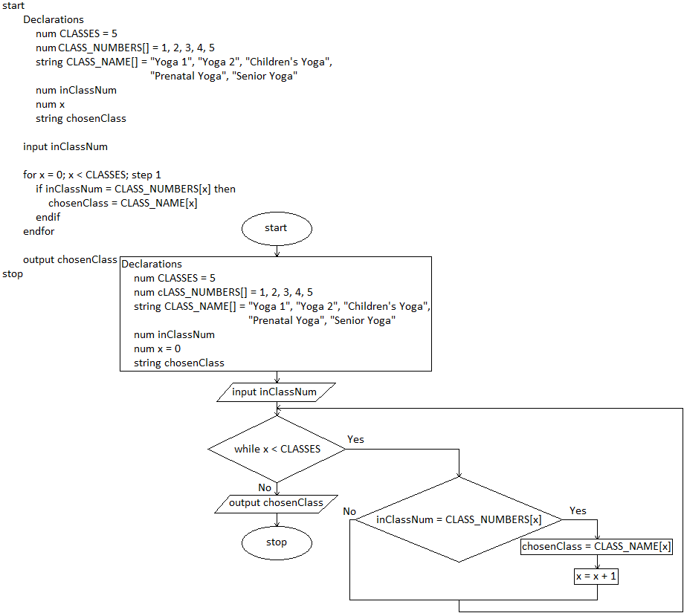

Exercise 5b Flowchart & Pseudocode.

